Instructions for Downloading Records from the Meditech MHealth Portal

(Hospital Portal)

You may begin the download request on a phone. However, when the records are ready to download, you must be on a tablet or a computer.

Go to our hospital portal login page: Patient Portal Sign In: Stillwater Medical Multi Hospital Portal

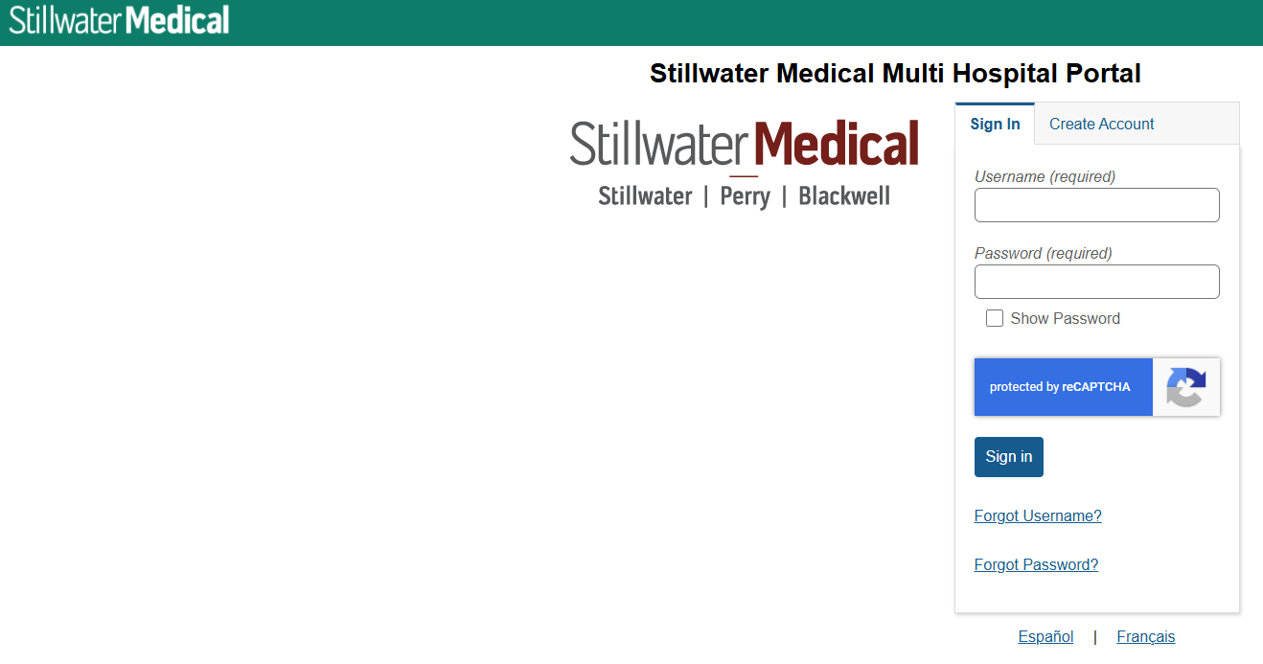

Log in with your username and password.

On the left side of the page, click “Health Record.”



Scroll down to the “Download Medical Record” section.

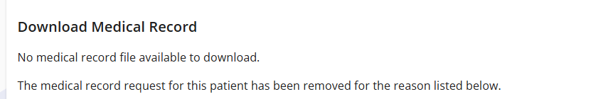

Click the button at the bottom of that section that says, “Request Medical Record.”


You will see this message:

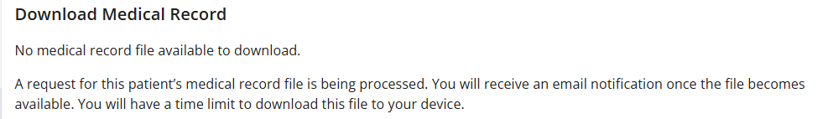

Below that you will see the file status:

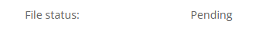

You will receive an email when the file is ready to be downloaded.

Log in to your portal again from a tablet or computer and click “Health Record” and “Download Medical Record” as you did before. You will see instructions for downloading and that the file status has changed from “pending” to “ready.”

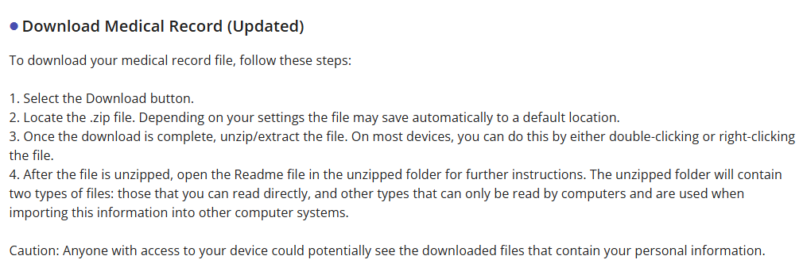

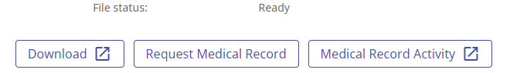

Your visits will be labeled by visit number rather than date of service so to figure out which visit number to open, click the “read me” file that will be part of your download. It will tell you which dates match each visit number.

