View, Download and Transmit CCDAs
Patients and authorized representatives can view, download, and transmit their health information via CareSpace. Built based on regulatory guidelines, this feature promotes interoperability and enables patients to securely share their records with another provider.
From the “Health” page, patients have the ability to “Send Record” or “Download” their CCDA.
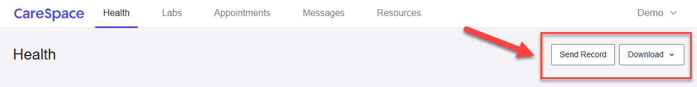
When sending their record, patients should include the following:
- The recipient's email address
- The desired Start and End date of medical information
- Any notes for the recipient
- A password for security and encryption purposes
